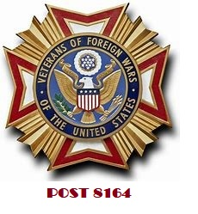
Greetings to All
We are seeking donations/sponsors/players for our fourth annual golf tournament being held on Monday September 11, 2023 at Merrimack Valley Country Club in Methuen. Our annual golf tournament provides us the means to support our mission which is to foster camaraderie among United States veterans of overseas conflicts and to serve our veterans, the military, and communities and advocate on behalf of all veterans.
All monies collected will be expended in support of the VFW programs as follows:
- Maintenance and expansion of the VFW National Home for Children and other facilities devoted exclusively to the benefit and welfare of dependents, surviving spouses and orphans of needy or deceased Veterans or members of the Armed Forces.
- Necessary expenses in providing entertainment, care, and assistance to hospitalized veterans or in house members at the Bedford VA.
- Veteran’s rehabilitation, welfare, and service work.
- To foster true patriotism through historical and educational programs such as VFW’s Patriot Pen and Voice of Democracy scholarship programs.
Last year we supported SMGA and Clear Path for Veterans of New England. This year we will be supporting Veterans Northeast Outreach Center (https://vneoc4vets.org/), who help Homeless Veterans find shelter and work towards stability and self-sustainment.
In partnership with Golf Status, we have gone digital on this year’s tournament. To register teams/individuals, donations, sponsorship packages and all extras please visit our tournament website at https://events.golfstatus.com/event/181fd06f-6c72-40a8-94fd-2d26847d8cbc/details/registration-details .
For more information in donating or sponsoring our event please visit our website at vfw8164.org or call 978.284.9880 and/or email: Adj@vfw.org.
VFW Post 8164-Tewksbury, MA is a 501c Non Profit Organization.

